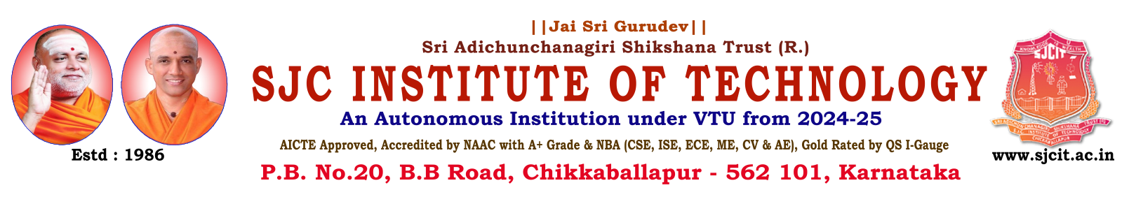
Department Of Physical Education & Sports

VTU Inter-Collegiate Bangalore North Zone & Inter Zone Various Sports Events- 2024-25

VTU Sports Event Participation

Games Participation Details
Games | Men | Women
Kabaddi | 12 | 12
Volley Ball | 12 | 12
Cricket | 15 | 00
Badminton | 06 | 05
Table Tennis | 06 | 04

VTU University Players

- Mr. Bhargav V (7th Sem CSE) and Mr. Gagan Gowda (3rd Sem CSD) have been selected to represent the VTU Team in the South Zone Inter-University Kabaddi (Men) Championship.

- Ms. Chaitanya N (1SJ23CG010) and Ms. Deepthi M R (1SJ22CG020) have been selected to represent the VTU Team in the South Zone Inter-University Kabaddi (Women) Championship.

- National Festivals and Celebrations
Our institution proudly organized and celebrated the following national festivals:

- Independence Day Celebrations:

- Sports Achievements
- We are proud to announce the following achievements by our students and staff in various sports competitions:

- Student Achievements:
- The SJCIT Badminton (Men) Team Emerged As Runners-Up In The VTU Bengaluru North Division Badminton Championship 2025, Held On September 9th, 2025 At Brindavan College Of Engineering, Bengaluru.

VTU University Players
Mr. Bhargav V (7th Sem CSE) and Mr. Gagan Gowda (3rd Sem CSD) have been selected to represent the VTU Team in the South Zone Inter-University Kabaddi (Men) Championship.
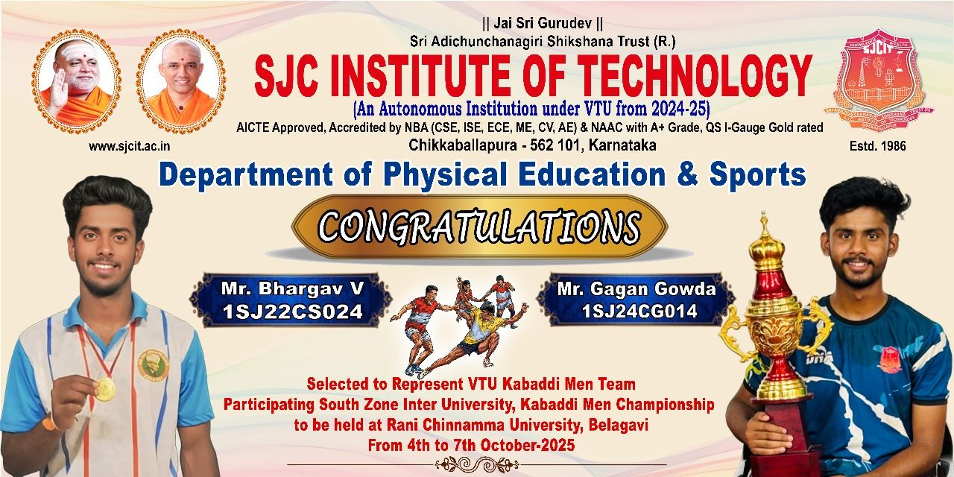
Ms. Chaitanya N (1SJ23CG010) and Ms. Deepthi M R (1SJ22CG020) have been selected to represent the VTU Team in the South Zone Inter-University Kabaddi (Women) Championship!
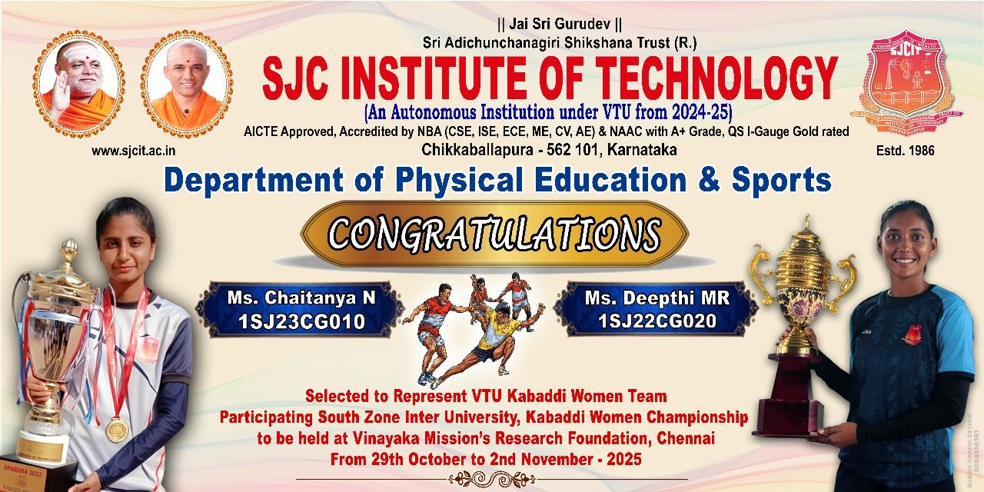

- National Festivals and Celebrations
Our institution proudly organized and celebrated the following national festivals:

- Independence Day Celebrations:
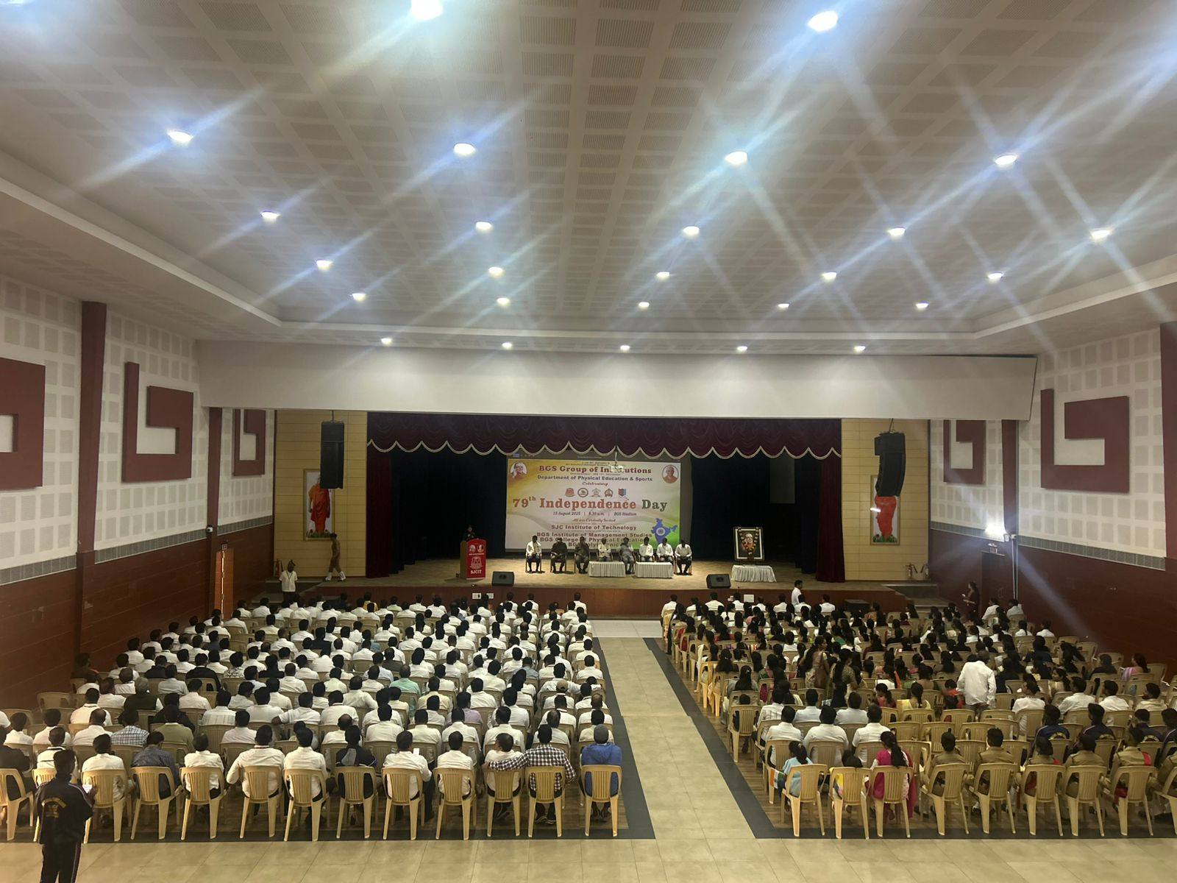

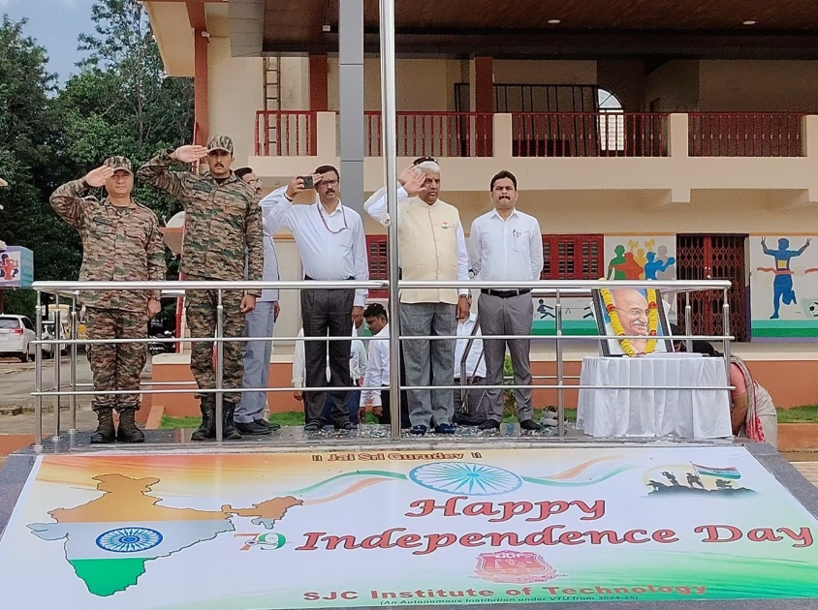
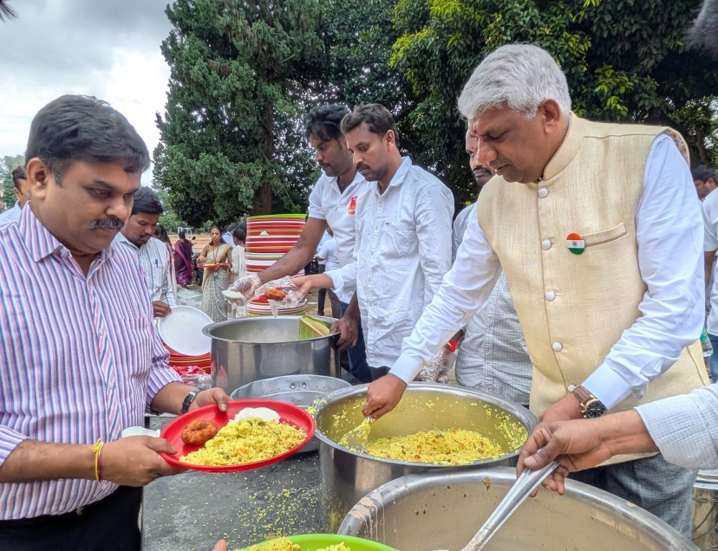
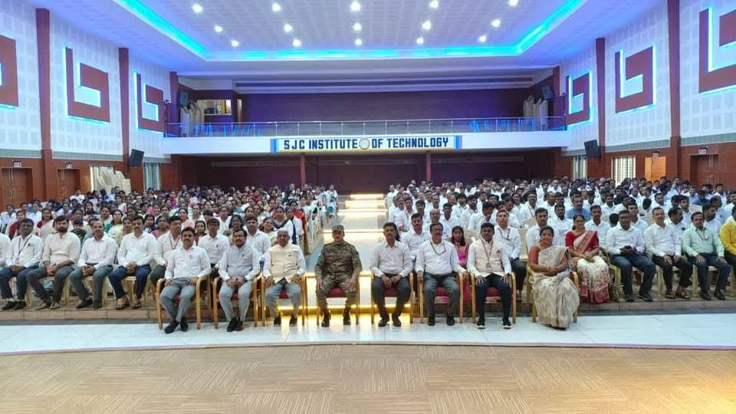

The SJCIT Badminton (Men) Team Emerged As Runners-Up In The VTU Bengaluru North Division Badminton Championship 2025, Held On September 9th, 2025 At Brindavan College Of Engineering, Bengaluru.
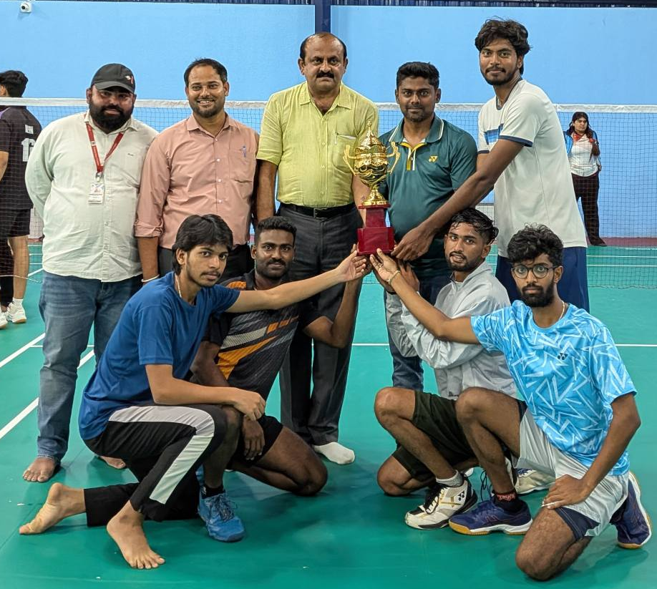

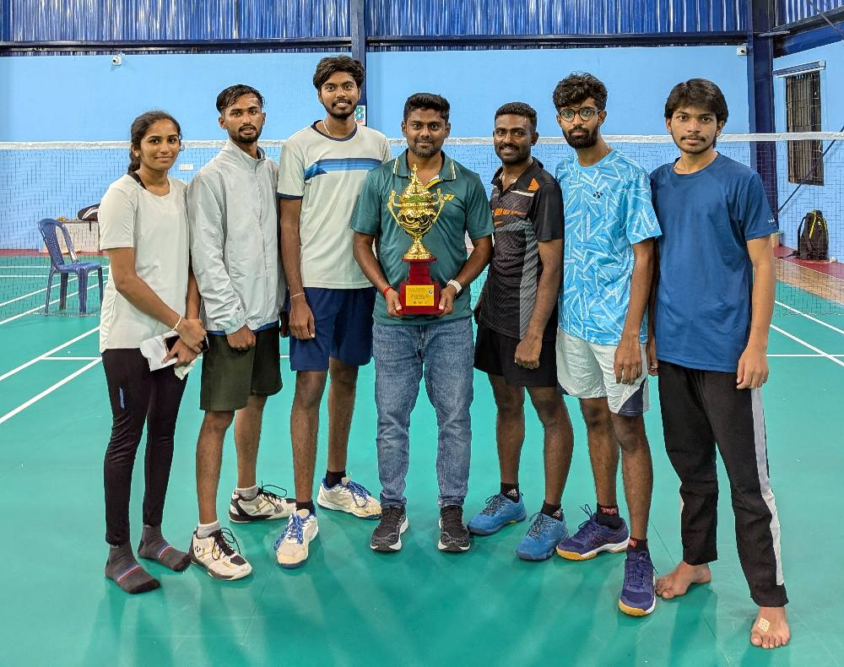

Ayudha Puja 2025

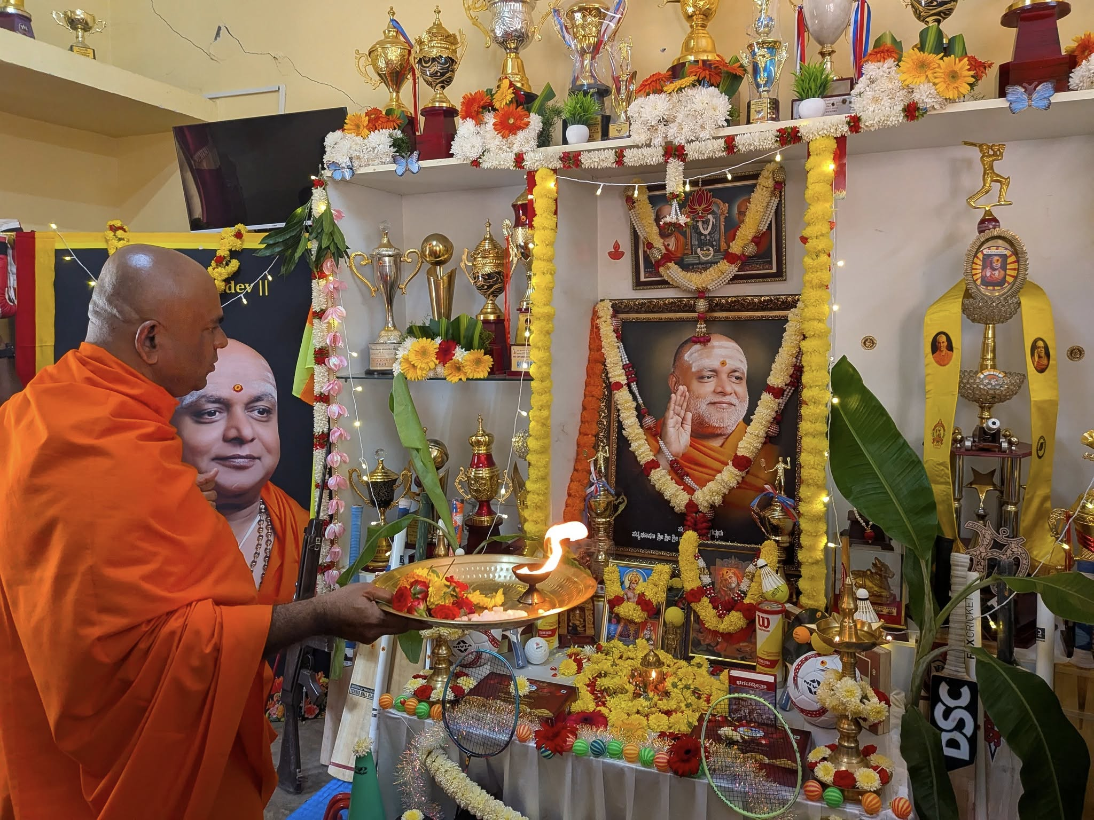
The Sports Department was honored to host the sacred Ayudha Puja, graced by the blessings of Poojya Sri Sri Mangalanath Swamiji.

